Odoo Field Service – Manager Guide

Contents

Stages 1

Sub-Status 2

Tags 3

Teams 4

Geo-Location Hierarchy 4

Regions 5

Districts 5

Branches 5

Territories 5

Worker Categories 6

Worker Skills 7

# Stages

Stages are used to move items through a process. Stages can be created for Orders, Workers, Equipment and Locations.

**NOTE**: Changes to Order stages should be limited to specific field updates described in this guide as other workflows and rules rely on the Order stages and making extensive changes can break workflows and functionality.

User with Manager permissions can open and edit stages:

1. In the Field Service App, go to **Configuration** then **Stages**.
2. Open the Stage you want to edit

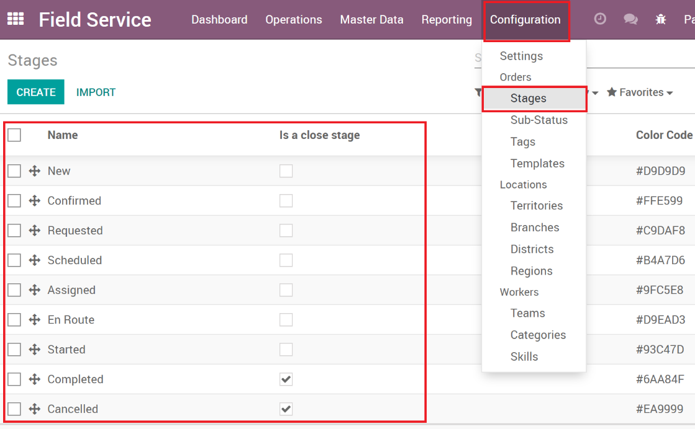

1. Set the fields that are needed for the stage.

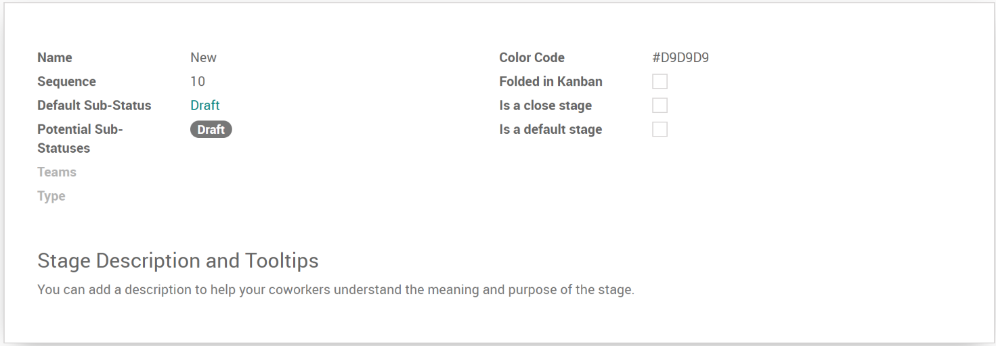

Field List:

* 1. **Name**: Name of the stage and what shows in views and forms.
  2. **Sequence**: The order this stage will show. In the stage list view, you can also drag/drop the stages to set the order.
  3. **Default Sub-Status:** The sub-status that will auto set when an item is moved to the stage.
  4. **Potential Sub-Status**: The list of sub-statuses available when the order is in this stage.
  5. **Teams**: Sets the teams for which this stage is available for.
  6. **Type**: What record types the stage applies to (Orders,
  7. **Color Code**: The HTML color that is used when showing items on the Gantt and Map views.
  8. **Folded in Kanban**: Determines whether the stage is folded on Kanban views.
  9. **Is a close stage**: Set the stage as a closing stage (e.g. canceled or completed).
  10. **Is a default stage**: Sets the stage to be a default stage when records are created.
  11. **Description**: Describes the purpose of the stage for employees to better understand the purpose of the stage.

# Sub-Status

Sub-Status gives another layer of organization for Orders and can be fully customized and linked to stages. The sub-status can be used to give the user additional information about what status the Order is in. Sub-Statuses can only be configured by users with the manager permissions.

1. Go to **Configuration** then **Sub-Status**

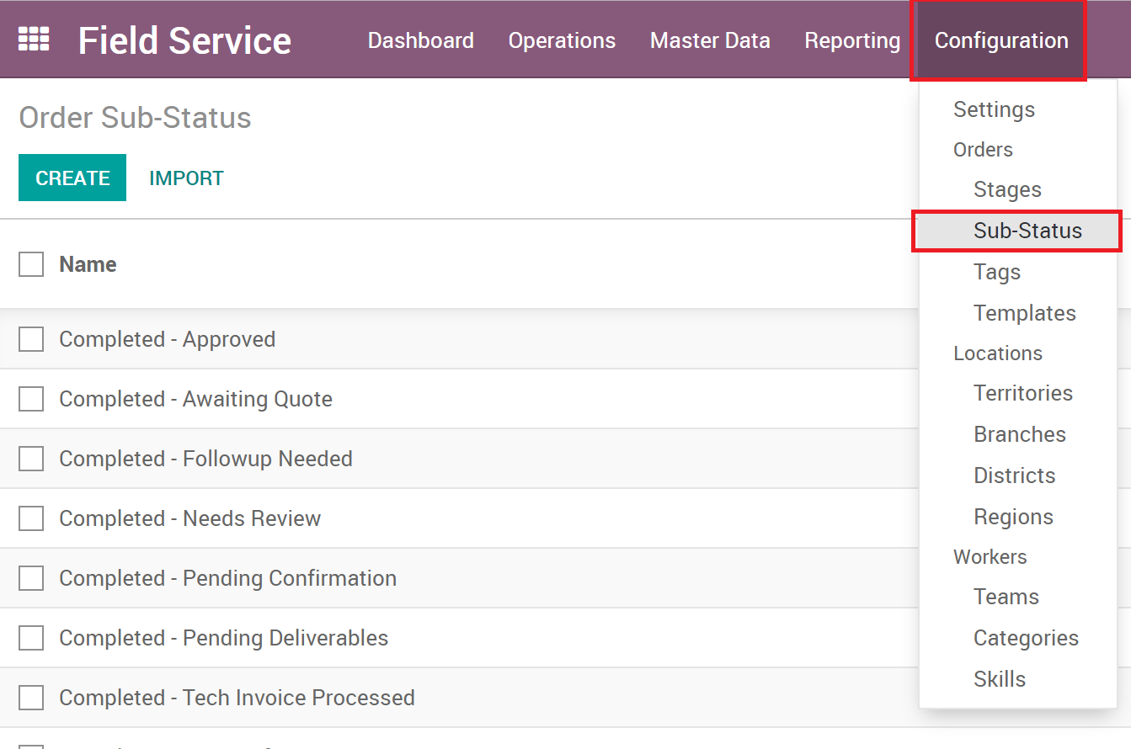

1. **Open** or **Create** a Sub-Status
2. Enter the **Name** of your sub-status

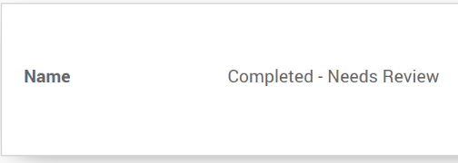

1. To apply the sub-status to a stage, open the stage that will have the new sub-status available on and add it to the sub-status fields.

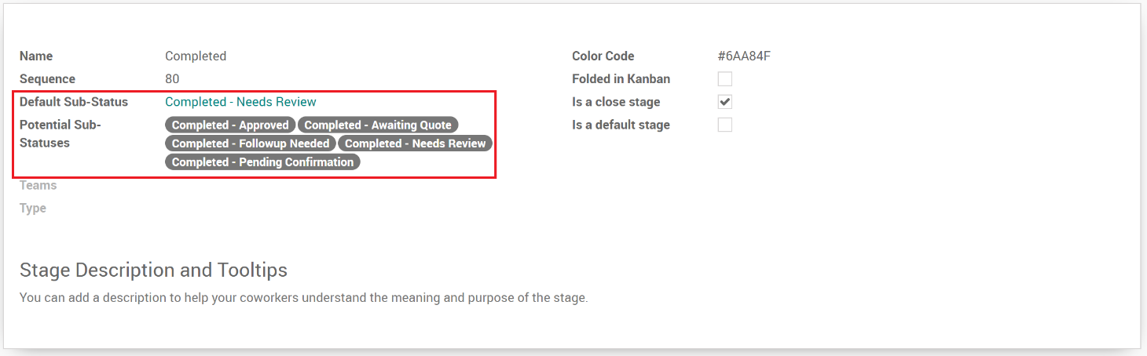

# Tags

Tags on Orders can be used as another tool to add additional categories or descriptive items to assist with reporting.

1. Go to Configuration then Tags

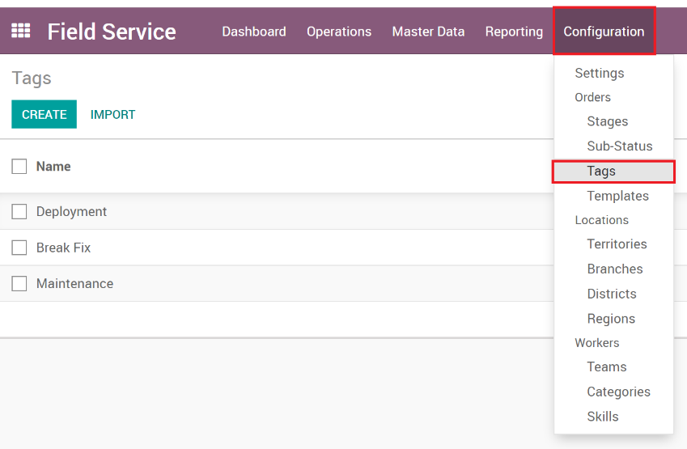

1. **Open** or **Create** a tag

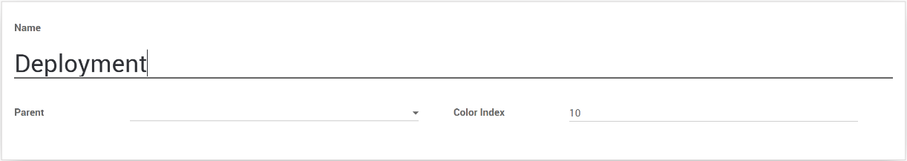

Tag Fields:

* 1. **Name**: The name of the tag that shows to users.
  2. **Parent**: Tags can have parents, so you can organize sub-tags under a parent tag.
  3. **Color Index**: Tags can be colored, so you can either set the color by number here or right click the tag when added to an Order then choose the color there.

1. Now that the tag has been created it can be seen and used by users to add to orders.

# Teams

Orders can be assigned to teams. When Teams is activated, the Dashboard shows all the teams with their assigned orders. Users with manager permissions can create and edit teams.

1. Go to **Configuration** then **Teams**

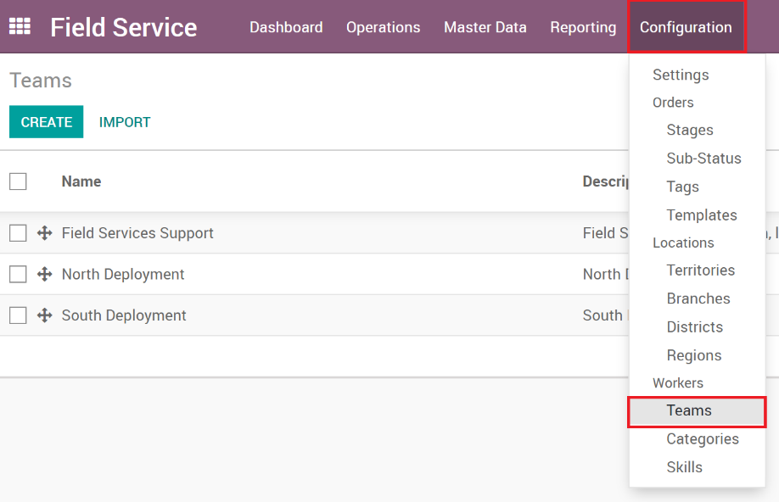

1. **Open** or **Create** a team

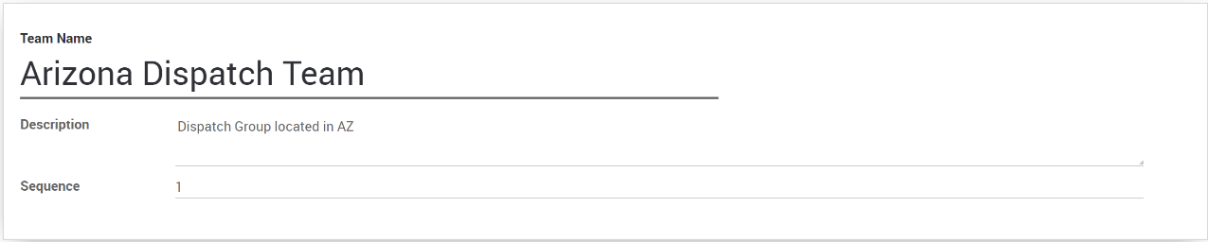

Team Fields:

* 1. **Name**: The name of the team.
  2. **Description**: Description of the team to help users understand the team’s purpose.
  3. **Sequence**: Sets the order that the teams show on the dashboard.

1. Once the team is created, users can select the team on the orders.

# Geo-Location Hierarchy

Field Service provides the ability to build a geo-location hierarchy which includes Regions, Districts, Branches and Territories. Workers can be assigned to one or more territories while Locations can be assigned to a single Territory. Each level of the hierarchy can also have a manager assigned to them. Users with manager permissions can edit and create regions

All the geo-location records are configured in a similar way and can be accessed via the Configuration menu.

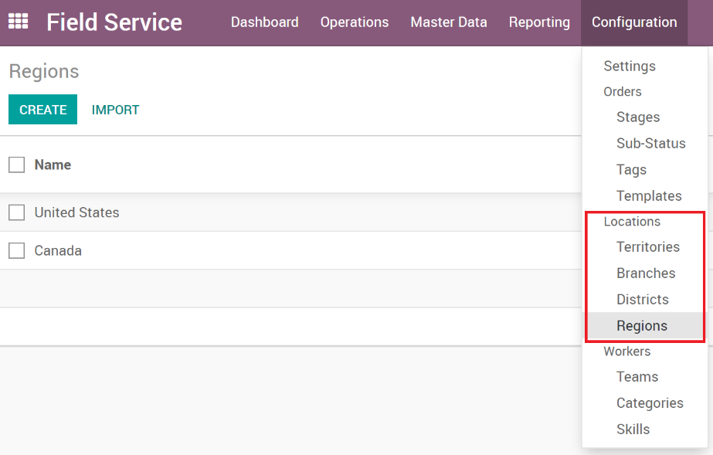

## Regions

Regions are the top level of the hierarchy and are considered the ‘parent’ of all districts.

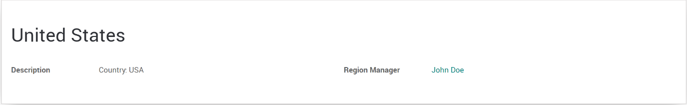

## Districts

Districts are the second layer of the hierarchy and are smaller units of division, with a parent region.

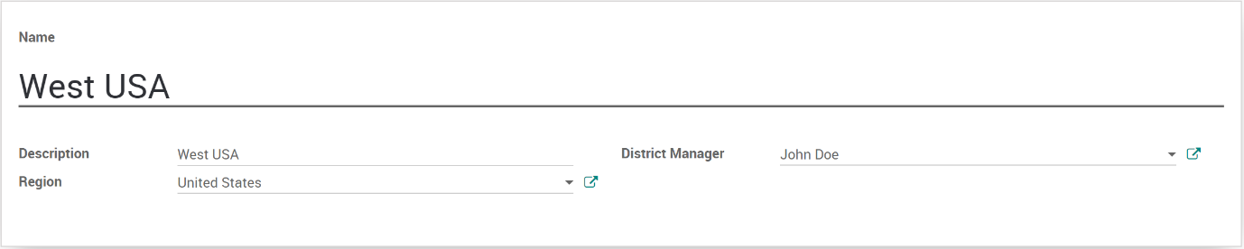

## Branches

Branches are the third layer of the hierarchy and are smaller units of division, with a parent district.

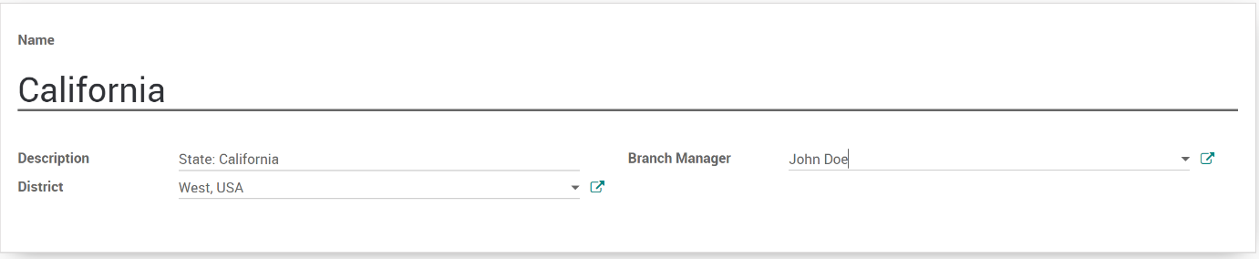

## Territories

Territories are the final level of the hierarchy, with a parent of branch, and are used to assign workers and locations.

**Note**: Currently territories are manually assigned, but the roadmap for these are to auto set based on zip codes and to include more geo-location services.

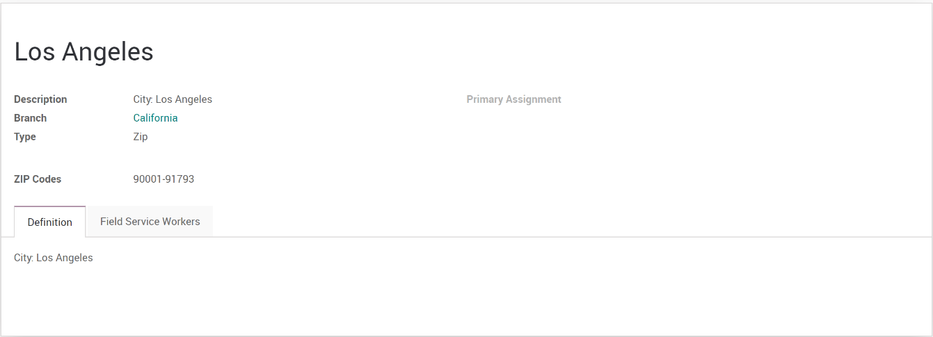

# Worker Categories

Workers can be assigned one or more categories. These categories are used on Orders and Order Templates to find the right worker for the job that has been requested. Users with manager permissions can edit and create categories.

1. Go to **Configuration**, then **Categories**

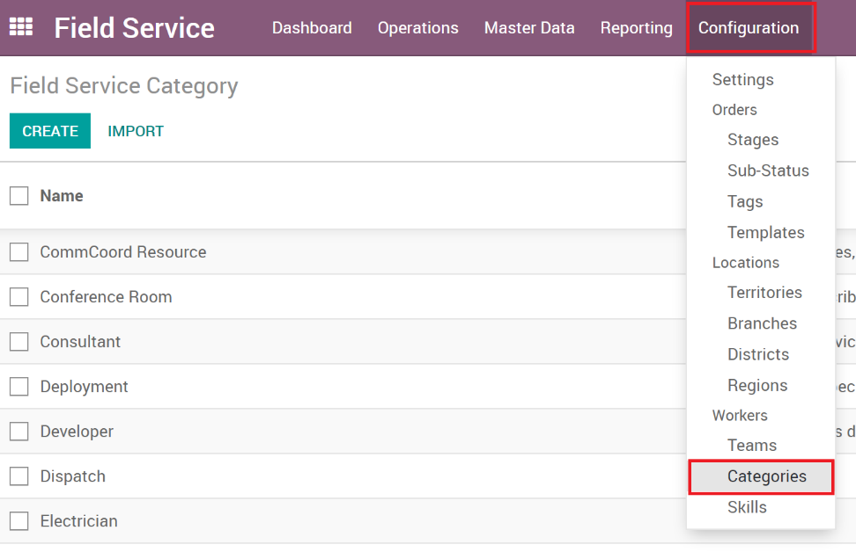

1. **Open** or **Create** a category.

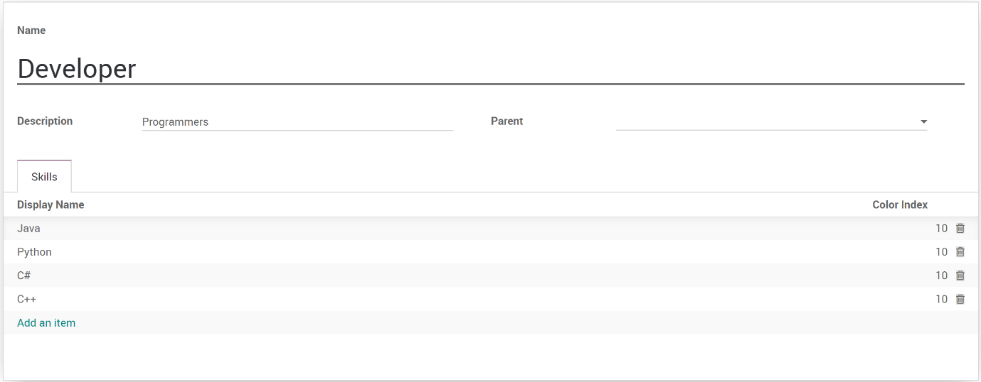

Fields

* 1. **Name**: The name of the category that users will see when selecting it.
  2. **Description**: The description to inform users what the category represents.
  3. **Parent**: Categories can have parents to organize larger lists of similar categories.
  4. **Skills**: Categories are related to skills and will filter the skills depending on the selected category.

1. Now the category can be set by users on Workers, Orders and Order Templates.

# Worker Skills

Workers are assigned skills and ratings for their skills. This helps determine the capabilities of the worker and what they have been trained to do.

1. Go to **Configuration** then **Skills.**

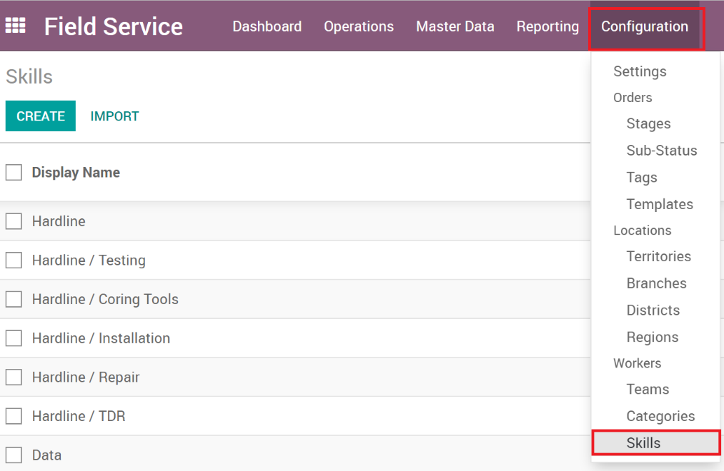

1. **Open** or **Create** a skill.

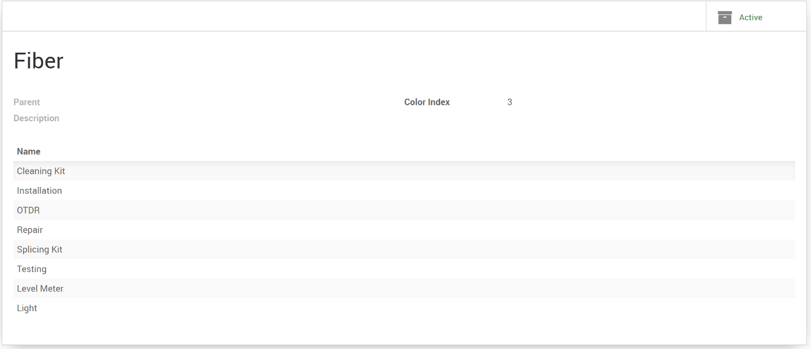

Fields:

* 1. **Name**: The name of the skill which shows for users when selecting it.
  2. **Parent**: Skills can have parent skills which are useful to group a bunch of related skills together.
  3. **Description**: Describes the skill and assists users with information about the skill.
  4. **Color** **Index**: Skills can be colored so the number represents a color. The skills color can be changed on the worker, order forms too.
  5. **Child** **Skills**: Since skills can have parents, this is where you can create additional child skills.

Once the skill has been created, they can be assigned to Workers, Orders and Order Templates.